2021 FRS YOUTH
TOUR APPLICATION
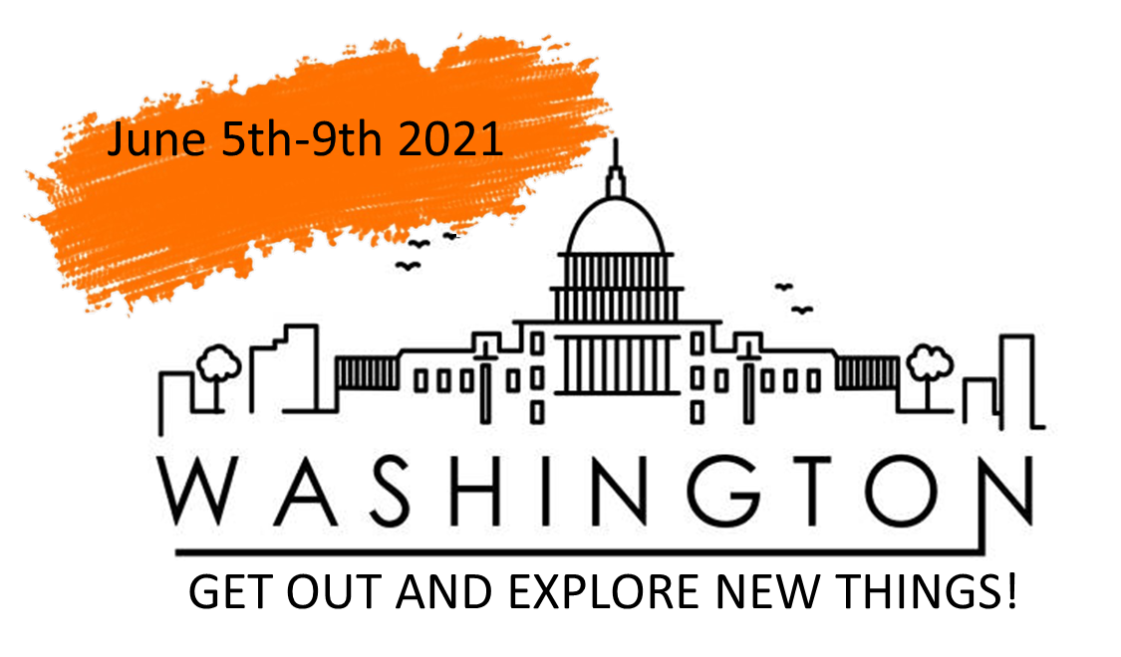

RAINBOW COMMUNICATIONS WILL SPONSOR TWO STUDENTS ON AN
ALL-EXPENSE PAID TRIP TO WASHINGTON D.C.

Youth Tour Overview
Each year Rainbow Communications and The Foundation for Rural Services send two students on a once-in-a lifetime trip to Washington D.C. During the FRS Youth Tour, attendees gain a first-hand look at the telecommunications industry, legislative and governmental processes, and they are given the opportunity to visit numerous historical sites. To learn more about the tour visit www.frs.org/youth-programs/youth-tour.
Rainbow will cover registration, travel, and tour expenses for two students (from different schools) to attend. Students also receive $150 spending money. The total tour value is over $1,800.

Applications MUST:
- Be 16 or 17 years old at the time of the Youth Tour, June 5-9, 2021.
- Receive at least one communication service from Rainbow Communications, whether it be phone or internet.

Dates of Importance:
Friday, February 12th: Applications, all material, and essay must be submitted to Rainbow Communications.
Wednesday, February 17th: Student(s) will be notified if he or she has been chosen to attend the 2021 Youth Tour.
Friday, February 19th: Once selected, registration paperwork must be submitted to Rainbow Communications by date.
June 5th-9th: Youth Tour Dates.

Return this application and supporting material to COMMUNITYRELATIONS@rainbowtel.com, or any Rainbow Communications location (Everest, Hiawatha, Seneca), or mail it to:
Rainbow Communications
Attn: FRS Youth Tour
513 Main St
Seneca, KS 66538

Please answer the following questions:

Questions:
- How has broadband helped you in rural Kansas during the Covid-19 Pandemic?
- What do you think the future of broadband will look like?
- How do you think broadband will affect your career?

Checklist:
This Photo by Unknown Author is licensed under CC BY-SA
- Applications must be completed in full and will not be considered if any information is not completed.
- Sign the certification located within the application.
- Have a high school teacher, guidance counselor, or principal complete the character evaluation and submit a letter of recommendation.
- Submit application and supporting material by Friday, February 12th.

Selection Process:
After the due date, the selection committee will review applications and choose 2 winners (from different schools) to attend the Youth Tour. Selected applicants will be notified on Wednesday, February 17th, if he or she has been chosen.

Applicant Information:

Name:
Date of Birth: Year in School:
Address:
City: State: Zip:
Phone:
Email Address:
High School: High School Phone:
Grade Point Average: If applicable, Weighted GPA:
Name of Parent(s) or Guardian(s):
Parent or Guardians Phone Number:
Parent or Guardian Email Address:
Please list the service(s) that you receive from Rainbow Communications:
Certification:
In submitting this application, I certify that the information provided is complete and accurate to the best of my knowledge. I agree that the selection Committee has my permission to verify any and all information. I understand that I must submit the application and all materials on or before Friday February 12th, to be eligible for consideration.

Signature of Applicant: Date:

Signature of Parent or Guardian: Date:

Activities:
Please list all school activities in which you have participated in during high school. (i.e., athletics, government, music, clubs, etc.) Attached additional page if necessary.
Activities | No. of Years Involved | Special Awards, Honors, Offices Held

Community Involvement:
Please list all non-paid community activities in which you have participated in during high school. (i.e., volunteer efforts, church work, etc.) Attach additional page if necessary.
Activities | Time Spent | Comments

Work Experience:
Since Starting School, list all work experience in chronological order, with your most recent job listed first. Attach additional page if necessary.
Company | Date of Employment | Position/ Job Description | Average Hours Per Week

Recommendation Letter and Character Evaluation (filled out by school officials)
- This form is to be filled out by one of your high school teachers, guidance, counselor, or principal.

School Official: Please place both forms in a sealed envelope before returning to applicant
Applicant’s Name:
High School:
School Official’s Name:
School Official’s Position:
Phone Number:

Recommendation Letter:
School Officials: Please submit a one-page typed letter describing the applicant’s strengths and potential for future success. We welcome any information that will help distinguish this applicant from others. Please include in what capacity, and how long you have known the applicant.

Character Evaluation:
Compare with other high school students, how would you rate this student in the following areas?
 | Average | Good | Very Good | Excellent (Top 5%)
Optimistic Attitude
Willingness to take Responsibility
Pride in School and Community
Maturity
Respect for Others
Academic Achievement
High Principles and Values

Signature of Assessor Date:

